
YENEPOYA INSTITUTE OF ARTS, SCIENCE, COMMERCE AND MANAGEMENT
BALMATTA, MANGALORE
YENEPOYA (DEEMED TO BE UNIVERSITY)

Low Level Design
on
Healthcare

Student Name: Anusree s nair

Industry Mentor: | Shahank korrem | Guided by: | Vikyath Shetty

Table of Contents

- Introduction. 6
  - Scope of the document. 6
  - Intended Audience 6
  - System overview. 6
- System Design. 6
  - Application Design 6
  - Process Flow. 6
  - Information Flow. 7
  - Components Design 8
  - Key Design Considerations 8
  - API Catalogue. 8
- Data Design. 8
  - Data Model 8
  - Data Access Mechanism 9
  - Data Retention Policies 9

- Interfaces 9
- State and Session Management 10
- Non-Functional Requirements 10
  - Security Aspects 10
  - Performance Aspects 10

- INTRODUCTION
The GuardianHealth system is a secure Healthcare Identity Management platform designed to protect sensitive patient and user data. It implements modern security principles such as Identity and Access Management (IAM), Multi-Factor Authentication (MFA), Single Sign-On (SSO), and Blockchain-based audit logging.

  - Scope of the document
This document covers the detailed design of the GuardianHealth system, including its core components, modules, and workflows. It focuses on the implementation of authentication, authorization, role-based access control, Multi-Factor Authentication (MFA), frontend components, backend services, API structures, database design, and the blockchain-based audit logging system

  - Intended Audience
This document is intended to help developers and stakeholders understand how different modules such as authentication, IAM, MFA, and audit logging are implemented within the GuardianHealth system.

1.3 System overview
GuardianHealth is a secure Healthcare Identity Management System built to protect user identities and sensitive medical data. It manages user access using IAM (roles and permissions), utilizes MFA for strong authentication, and supports SSO for easy login across multiple systems.

- System Design
The GuardianHealth system follows a client-server architecture where the user interacts with the system through a frontend interface, securely connecting to backend APIs, databases, and a blockchain logging system
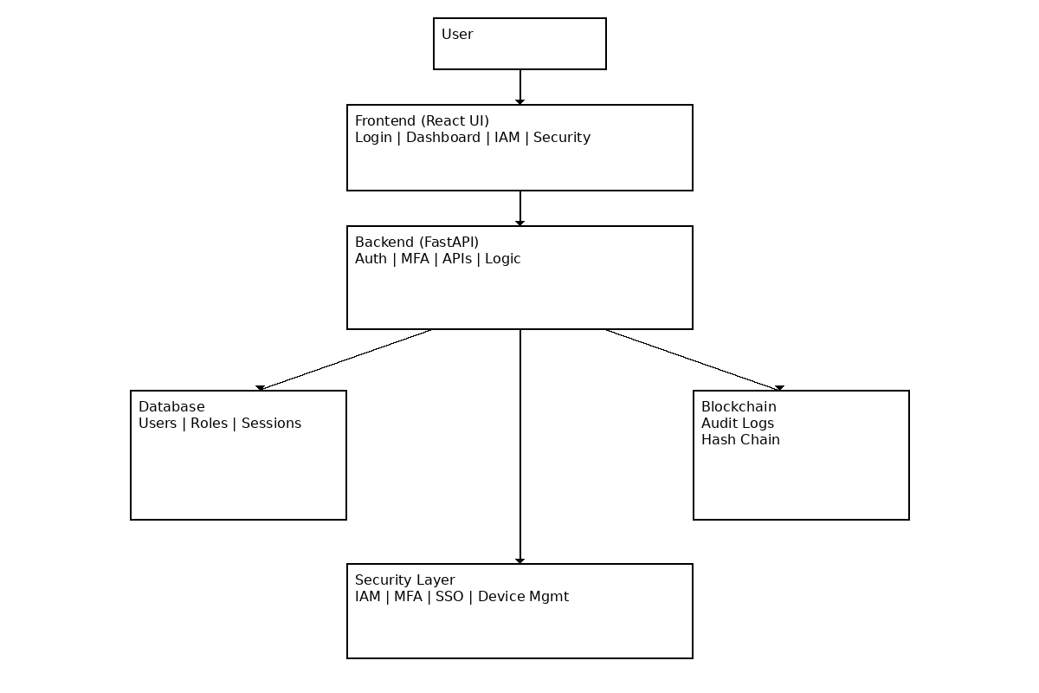
2.1 Application Design
The application is separated into a Frontend, Backend, and Database architecture deployed in the cloud:

- Frontend Architecture: Built using React.js with a component-based structure. It features a responsive design, sidebar navigation, and protected routes based on specific roles (Admin, Doctor, Patient, Staff). It is hosted on Cloud platforms like AWS or Azure.
- Backend Architecture: Built using Python (FastAPI / Flask) and hosted on a cloud server. It handles authentication & authorization, API endpoints, business logic, JWT-based authentication, and role validation.

- Database Architecture: Uses a managed SQL service (PostgreSQL/MySQL) to securely store user details, roles & permissions, sessions, audit logs, and MFA secrets

  - Process Flow

- MFA Flow: The user logs in, which triggers the Multi-Factor Authentication layer. The user then inputs a 6-digit Time-based OTP (TOTP), which is verified by the system to grant access

- SSO Flow: Utilizing OAuth2 / OIDC protocols, the user authenticates once. Access is then granted automatically across connected applications/systems

  - Information Flow

Data follows a strictly defined flow path through the system to ensure verification at each step:
User → Frontend → Backend API → Database (to store/retrieve data) / Blockchain (to log activity) → Response → Frontend → User

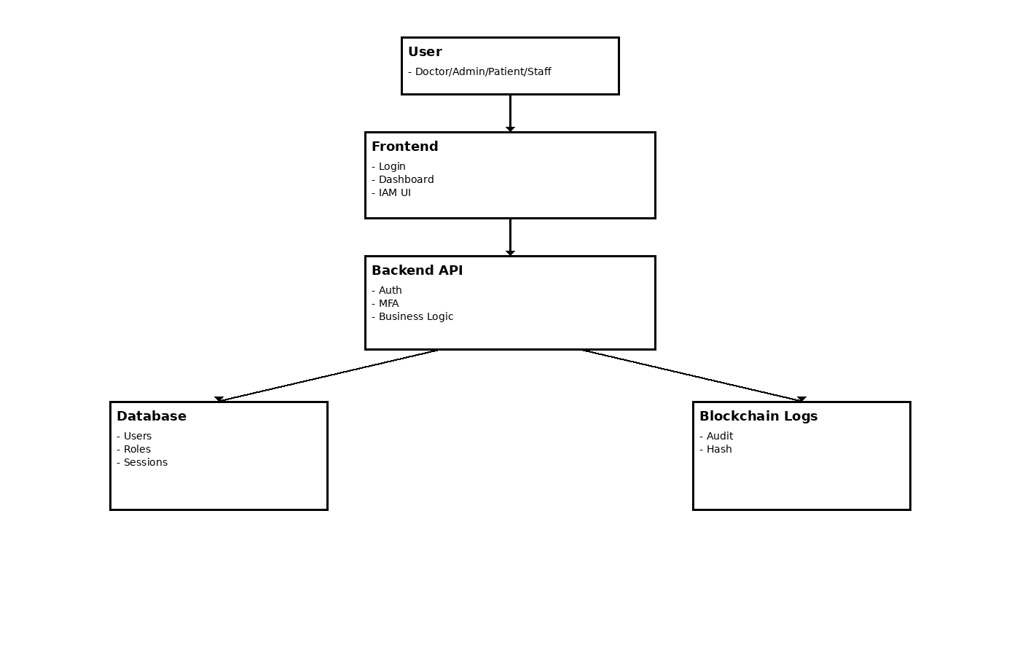

  - Component Design
The system is divided into multiple interconnected modules, each responsible for specific functionalities:

- Authentication Module: Handles login, registration, JWT generation, and SSO.
- MFA Module: Enforces TOTP generation and verification.
- IAM Module: Manages users, Role-Based Access Control (RBAC), and permissions.
- Dashboard Module: Provides role-specific views for Admins, Doctors, Patients, and Staff.
- Security Monitoring Module: Tracks alerts, logs, and detects risks.
- Blockchain Audit Module: Stores hash chains and tamper-proof logs.
- Session & Device Management Module: Tracks active sessions and known devices.
- Database & API Management Modules: Manages stored data and handles REST API communication

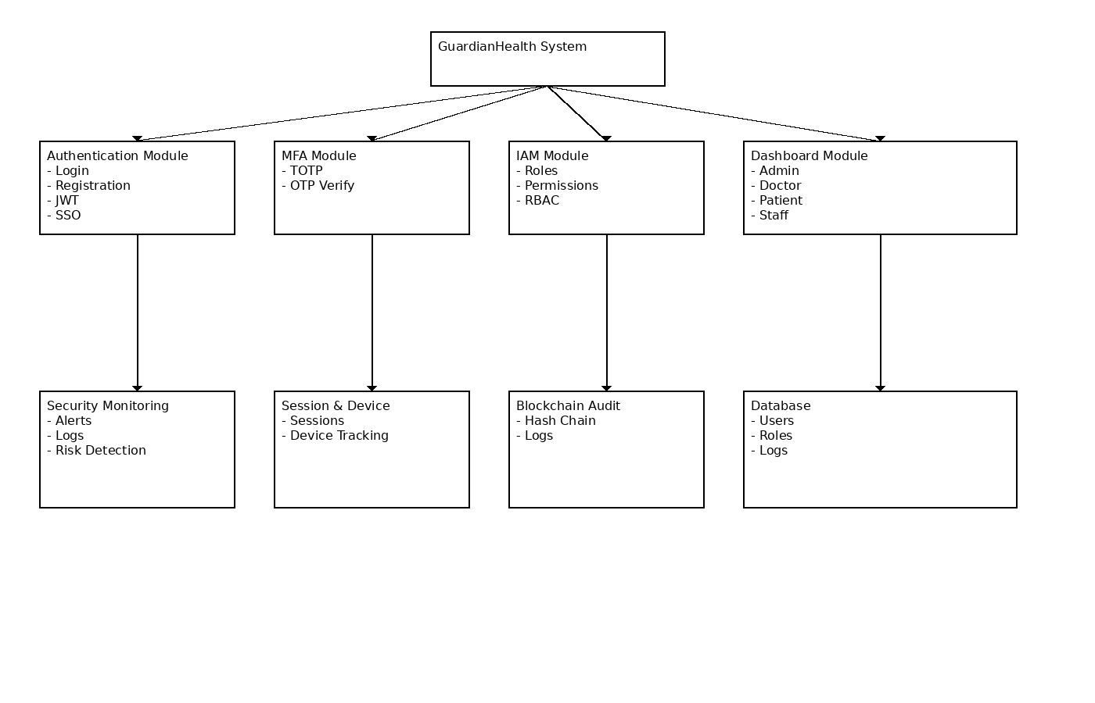

  - Key Design Consideration
- Zero Trust Architecture: Continuous verification is required. Every request is treated as though it
originates from an open network.
- Least Privilege Access: Users are only granted the specific
- Secure Storage: Passwords are mathematically hashed using bcrypt, and all sensitive data is securely encrypted.
  - API Catelogue
The API Management Module is responsible for all communications between the React frontend and the Python backend. It provides REST API endpoints, secures them using robust JWT authentication, and comprehensively validates all incoming requests and outgoing responses.
- DATA DESIGN
The application relies on a Relational Database (SQL – PostgreSQL/MySQL) tailored for scalability, security, and strict data integrity. Data integrity is upheld using primary keys, foreign keys, and constraints (NOT NULL, UNIQUE) to prevent duplicate or invalid data.

  - Data Model
The database is structured into multiple mapped tables:
- Users Table: Stores core identity information (name, email, hashed password, role, MFA status).

- Roles & Permissions Tables: Defines roles (Admin, Doctor, Patient, Staff) and specific privileges (e.g., view_patient, manage_users), linked via a Many-to-Many mapping table (Role_permission)

- Sessions & Devices Tables: Tracks JWTs, IP addresses, login times, expiry times, and trusted devices

- MFA Table: Stores the user's secret_key and verification status

- Audit Logs Table: Contains the blockchain logic fields (action, timestamp, previous_hash, current_hash)

- Relationships: One User → One Role; One Role → Many Permissions; One User → Many Sessions / Audit Logs / Devices; One User → One MFA record

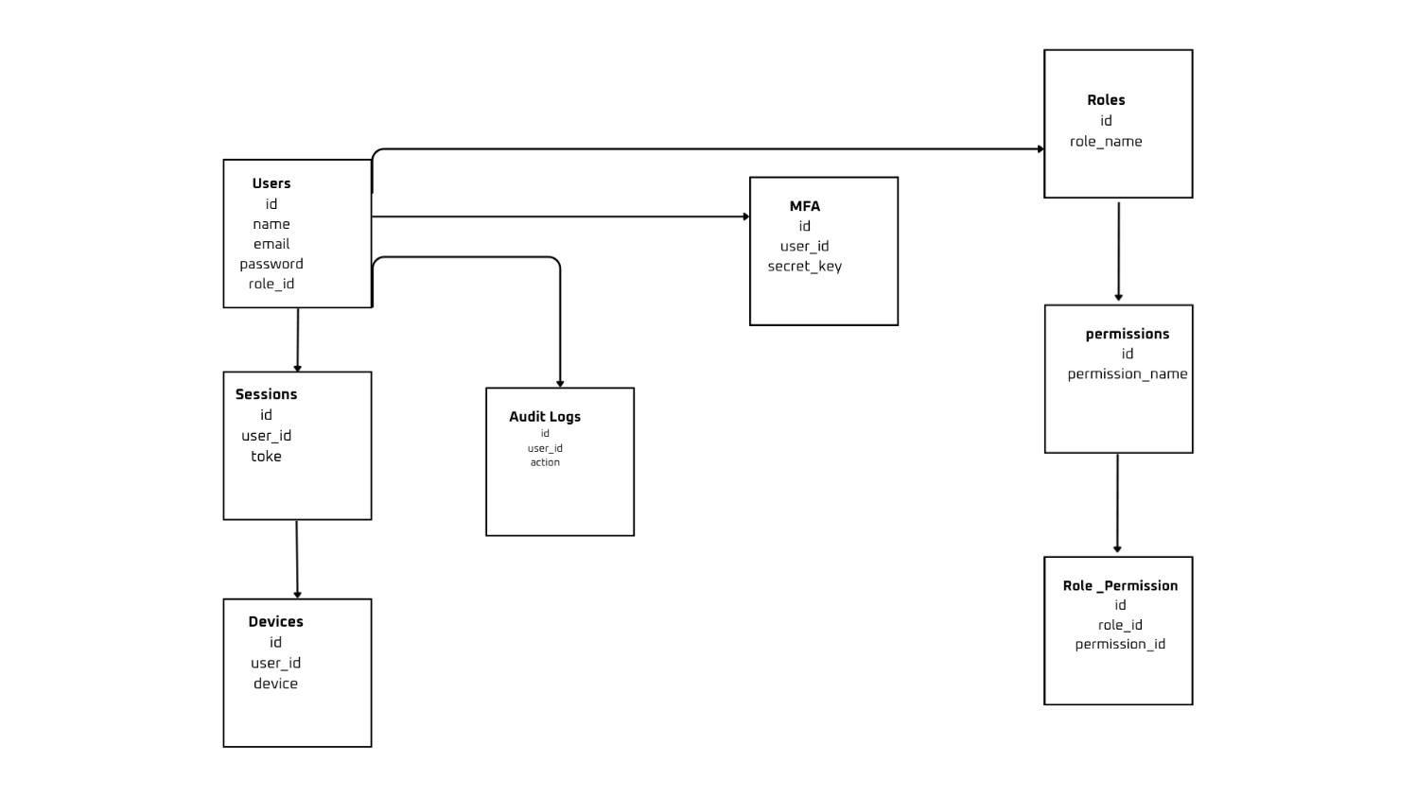
  - Data Access mechanism
Data is accessed via the Backend API layer, which acts as a gatekeeper. It strictly implements the Identity and Access Management (IAM) module policies, ensuring Role-Based Access Control (RBAC) verifies the user's role before processing database reads or writes.

  - Data Retention Policies
While standard purging policies are not explicitly detailed, the system's Blockchain Audit Architecture guarantees immutable retention of activity history. All data regarding user actions (login tracking, data access monitoring) is permanently stored as tamper-proof log chains linked by cryptography (previous hash/current hash.
- INTERFACE
The system's user interfaces are built with React.js using a responsive, dark-themed component architecture.
- Authentication Interfaces: Login/SSO page, Registration page with file upload for verification, and the MFA OTP input screen

- Role-Based Interfaces: Admin dashboards for user management; Doctor dashboards for medical records and prescriptions; Patient dashboards for personal records and consent management; Staff dashboards for vitals and task management.

- Shared & Security Interfaces: Navbars, sidebars, active session trackers, an IAM panel, and the Blockchain Audit Log component indicating tamper-proof verification.

5 STATE AND SESSION MANAGEMENT
State and sessions are centrally managed by the Session & Device Management Module. When a user logs in, a JWT token is generated and recorded in the Sessions table along with device and IP information. The system continuously monitors these sessions, allowing users to remotely log out of specific devices and alerting them of new or unknown device logins.

6 NON -FUNCTIONAL REQUIREMENTS
- UI/UX: The system requires a responsive design for both mobile and desktop, smooth transitions, loading indicators, and a professional dark theme.

- Error Handling: The system gracefully handles invalid inputs, expired OTPs, and unauthorized API access via backend validation and clear UI error messages without exposing sensitive data to prevent system crashes.

- Testing: Independent component unit testing (via frameworks like Pytest) covers authentication logic, API responses, and edge cases to improve code reliability.

6.1 SECURITY ASPECTS
Security is the core component of GuardianHealth. Security layers include:
- Authentication: Passwords hashed with bcrypt, mandatory TOTP MFA, and active session/device tracking.

- Authorization: IAM Module executing strict Role-Based Access Control (RBAC) and Least Privilege Access policies.

- Auditing: A specialized Blockchain Audit Module that utilizes hash chaining to securely log and track user actions, making audit trails immune to tampering

- Monitoring: Active risk detection, login failure alerts, and IP tracking

6.2 Performance Aspects
The architecture is designed to support real-world scalability and high performance. This is achieved by separating the frontend, backend APIs, and database components, allowing each layer to be hosted and scaled independently via managed cloud infrastructures like AWS or Azure.

